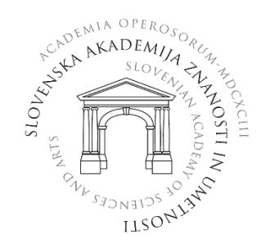
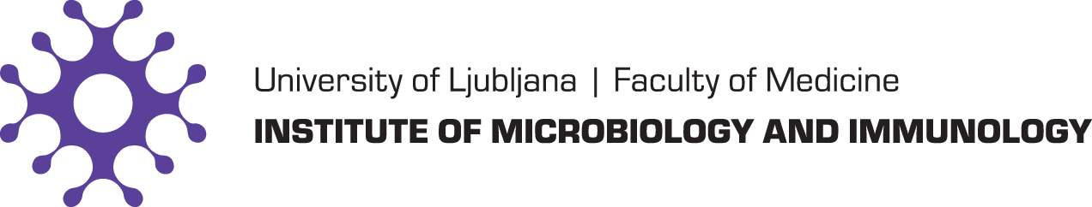
a

INVITATION

4. INTERACADEMIC SCIENTIFIC SYMPOSIUM
»Emerging zoonoses – continuous challenge«

The Slovenian Academy of Sciences and Arts and
the Institute of Microbiology and Immunology
invite you to the 4th Interacademic Scientific Symposium,
which will be held on October 6 and 7, 2022 in the Central Lecture Hall of the Faculty of Medicine, University of Ljubljana, Slovenia.

The symposium will be held in English and in a hybrid format (live and online). To register for the symposium, please complete the form APPLICATION FORM by September 28, 2022.

You are cordially invited to attend.

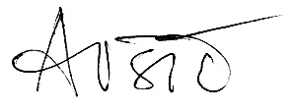

Akad. prof. dr. Tatjana Avšič - Županc

