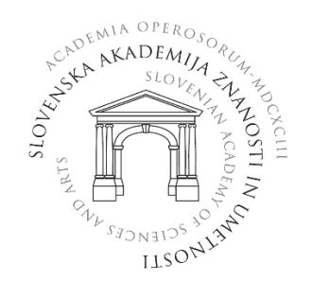

APPLICATION FORM

4. INTERACADEMIC SCIENTIFIC SYMPOSIUM
»Emerging zoonoses – continuous challenge«

Last and first name:
Organization:
E-mail address:
Registration: | - Thursday, October 6, 2022  - Friday, October 7, 2022
Participation: | - live  - online  - poster presentation

Send the completed registration form to zoonoze@imi.si no later than September 28, 2022.

