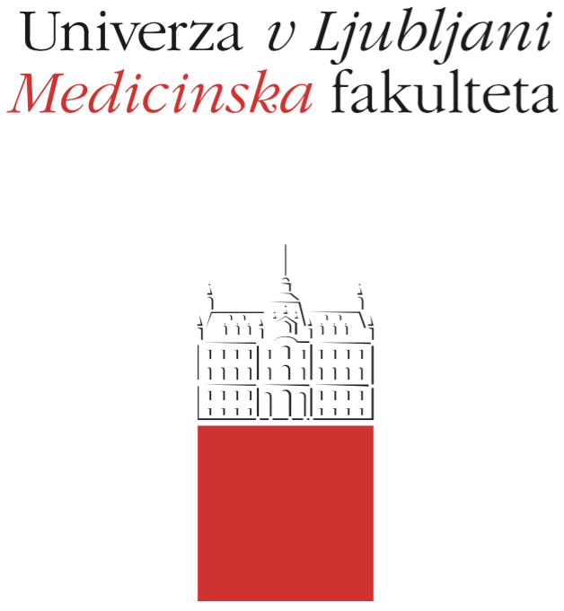

Komisija za študijske zadeve

UL Medicinske fakultete

Vrazov trg 2

SI-1000 Ljubljana

E: ksz@mf.uni-lj.si

T: +386 1 543 7700

Course Regime

Course: INTRODUCTION TO MEDICINE: MODULE INTRODUCTION TO PUBLIC HEALTH

Study Programme:
Medicine Dental Medicine

Year of the Course: 1 2 3 4 5 6

Semester:
Winter Summer

Course type:
Compulsory Elective

Number of ECTS credits: 1

Lecturer(s): prof.dr. Lijana Zaletel-Kragelj

Participating Organisational Units (Departments and Institutes): Chair of Public Health

Parts (Modules) of the Course
The module is the part of the INTRODUCTION TO MEDICINE course.

Date of Issue: Sepember 15, 2018

A. General part
- Course objectives
OBJECTIVES
The objectives of the training are as follows:
- to introduce students to the basics of public health concepts,
- to introduce students to the importance of public health medicine for the health of the population,
- to introduce students to the importance of health for society.

COMPETENCES
The competences expected are only first-level competences, so at the end of the module it is expected that students:
- know and understand the basic concepts of public health,
- know and understand the importance of public health medicine for the health of the population,
- know and understand the importance of health for society.

- Comprehensive outline of the course organisation
Module INTRODUCTION TO PUBLIC HEALTH is carried out only as lectures (15 hrs of lectures), that take place jointly for students of Medicine and Dental medicine programmes.
All notices about the lectures (location, exact timetable, dates and location of colloquium and final exam) in the course INTRODUCTION TO MEDICINE: MODULE INTRODUCTION TO PUBLIC HEALTH is published in the UL MF online classroom and on the UL MF website.

- Description of on-going assessment of knowledge and skills
Process evaluation of knowledge (course colloquium) in the module is in the form of 15 MCQ questions with one correct answer (the correct answer can be a combination of several basic independent answers).
Each question is worth 1 point. There are no negative or partial points. Student can collect up to 15 points. Depending on the number of points accumulated, the final assessment of the course colloquium in the module is made as follows:
Insufficient (1-5) 0-7 points
Sufficient (6) 8 points
Good (7) 9 points
Very good (8) 10-11 points
Very good (9) 12-13 points
Excellent (10) 14-15 points
The assessment contributes proportionally to the overall assessment in the course INTRODUCTION TO MEDICINE.

- Required conditions for the final examination (Course Exam)
There are no required conditions for the approach to the final examination.
- Final assessment and examination of knowledge and skills (Course Exam)
Summative (final) evaluation of knowledge (course exam) in the module is in the form of 15 MCQ questions with one correct answer (the correct answer can be a combination of several basic independent answers). Each question is worth 1 point. There are no negative or partial points. Student can collect up to 15 points. Depending on the number of points accumulated, the final assessment of the course colloquium in the module is made as follows:
Insufficient (1-5) 0-7 points
Sufficient (6) 8 points
Good (7) 9 points
Very good (8) 10-11 points
Very good (9) 12-13 points
Excellent (10) 14-15 points
The assessment contributes proportionally to the overall assessment in the course INTRODUCTION TO MEDICINE.

- Other provisions
A refusal of a positive examination is not possible, but the student may again take the exam as determined in the Rules on the assessment and assessment of knowledge and skills for a uniform master's study program Medicine and Dental Medicine: a student may, at the time of study, correct a positive examination once at a maximum of ten objects selected by him himself, except for the grade obtained at the commission examination. NOTE: this provision applies to the exam in the INTRODUCTION TO MEDICINE course as a whole, and not to the individual module within this subject.
People with special needs can perform all forms of up-to-date and final examinations up to 50% more time.

- Fundamental study material and Supplement reading
PRIMARY STUDY MATERIAL
Zaletel-Kragelj L, editor. Introduction to public health. Study material (for internal use). Ljubljana: Faculty of Medicine, University of Ljubljana, Department of Public Health, 2017.
The material is available in the UL MF online classroom.

- Exam topics, clinical presentations and skills
EXAM TOPICS
1. Definition of public health and the field of its functioning
2. Historical development of public health and its importance for humanity
3. Health and disease
4. Introduction to health and the environment
5. Introduction to the study of the health of the population
6. Introduction to the methods of public health action
7. Introduction to major public health problems
8. Introduction to vulnerable and vulnerable population groups
9. Medical doctor/dentist and society

- Other information
/

