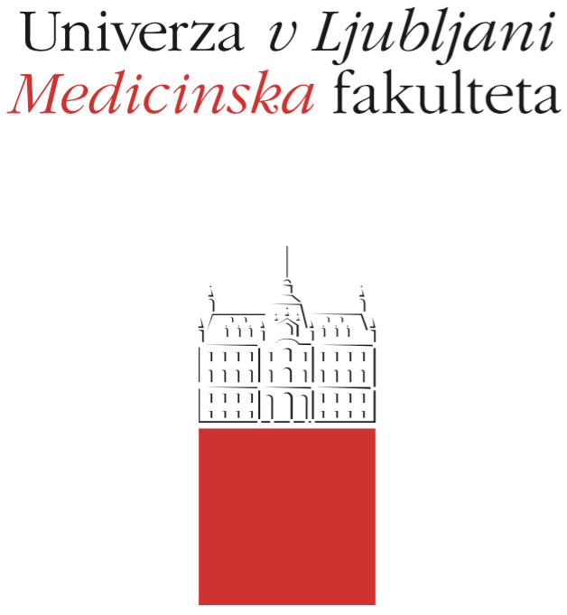

Komisija za študijske zadeve

UL Medicinske fakultete

Vrazov trg 2

SI-1000 Ljubljana

E: ksz@mf.uni-lj.si

T: +386 1 543 7700

Course Regime

Course: HEALTH AND ENVIRONMENT

Study Programme:
Medicine Dental Medicine

Year of the Course: 1 2 3 4 5 6

Semester:
Winter Summer

Course type:
Compulsory Elective

Number of ECTS credits: 5 (4+1)
Module 1 and Module 2: 4
Module 3: 1

Lecturer(s):
Module 1 and Module 2: prof.dr. Lijana Zaletel-Kragelj
Module 3: assoc.prof.dr.Aleš Fidler

Participating Organisational Units (Departments and Institutes):
Module 1 and Module 2: Chair of Public Health (CPH)
Module 3: Chair of dental diseases and normal morphology of the dental organ (CDDNMDO)

Parts (Modules) of the Course
Module 1: Basic determinants of health, social environment determinants of health
Module 2: Physical environment determinants of health, complex determinants of health
Module 3: Working environment of the dentist

Date of Issue: Sepember 15, 2018

A. General part
- Course objectives
Module 1 and Module 2
OBJECTIVES
Objectives of the course are:
- to introduce students to the influence of the basic risk factors on the health of the individual and the population,
- to introduce students to the influence of the basic and complex determinants of the social environment on the health of the individual and the population,
- to introduce students to the influence of the basic and complex determinants of the physical environment (natural and built environment) on the health of the individual and the population,
- to get to know students with the influence of complex determinants in which both, determinants of the social and determinants of the physical environment, intertwine.
The focus is on topics relevant to future dentists.

COMPETENCES
The competences expected are only first-level competences, so at the end of the module it is expected that students:
- know and understand the influence of the basic risk factors on the health of the individual and the population,
- know and understand the influence of the basic and complex determinants of the social environment on the health of the individual and the population,
- know and understand the influence of the basic and complex determinants of the physical environment (natural and built environment) on the health of the individual and the population,
- know and understand the influence of complex determinants in which both determinants of the social and determinants of the physical environment intertwine.

Module 3
OBJECTIVES
Objectives of the course are:
- to acquaint students with the workplace of the dentist
- to acquaint students with protective measures (mask, gloves, glasses)
- to acquaint students with the principles of ergonomics
- to acquaint students with instruments and devices used in clinical work

COMPETENCES
The student:
- is familiar with the working environment of the dentist
- knows and can use protective means (mask, gloves, glasses)
- can install himself and the patient in ergonomically appropriate positions
- knows the instruments and devices and the purpose of their use

- Comprehensive outline of the course organisation
Module 1 and Module 2
Teaching at MODULE 1 and MODULE 2 of the HEALTH AND ENVIRONMENT course is carried out in a total of 60 hours of organized lessons in the form of lectures and exercises:
- lectures (12 hours: in Module 1 6 hours and Module 2 6 hours), where the content framework of each module is presented,
- exercises (48 hours: Module 1 24 hours and Module 2 24 hours); exercises are performed in 6 seminar exercises (Module 1: 3 seminar exercises and Module 2: 3 seminar exercises); each seminar exercise is a thematic assembly lasting 8 hours (4 × 2 hours).
The attendance at the lectures is not mandatory, but is recommended. Presence at MODULE 1 and MODULE 2 seminar exercises is mandatory and is a prerequisite for conducting a course exam. A student can leave for one of the exercises for justifiable reasons. Justifiable reasons for absenteeism from the seminar exercise are: a disease or participation in a student's significant events such as, for example, sports, cultural or research events. The student must communicate an apology to the CPH office prior to the start of the exercise and, as soon as possible, to provide the written apology in the CPH office. If the student is absent due to disease, a certificate of absence from a physician who is treating a student is a valid written apology. If a student is absent due to participation in an important event for her/him, a written and signed apology from the organizer of the event is a valid apology. The student fulfils obligations at the missing seminar exercise in agreement with the coordinator of the seminar exercise. A student who deliberately fails the seminar exercise and can not present a valid apology can not replace the exercise.
All notices about the lessons (location, exact timetable) and examination (dates and location of partial and final exams) in the course ENVIRONMENT AND HEALTH is published in the UL MF online classroom and on the UL MF website.

Module 3
Teaching at MODULE 3 of the HEALTH AND ENVIRONMENT course is carried out in a total of 15 hours of organized lessons in the form of lectures and exercises:
- lectures (3 hours), where the content framework is presented,
- exercises (12 hours; 3 × 4 hours).
The attendance at the lectures is not mandatory, but is recommended. Presence at MODULE 3 exercises is mandatory and is a prerequisite for conducting a course exam. A student can leave for one of the exercises for justifiable reasons. Justifiable reasons for absenteeism from the exercise are: a disease or participation in a student's significant events such as, for example, sports, cultural or research events. The student must communicate an apology to the CDDNMDO office prior to the start of the exercise and, as soon as possible, to provide the written apology in the CDDNMDO office. If the student is absent due to disease, a certificate of absence from a physician who is treating a student is a valid written apology. If a student is absent due to participation in an important event for her/him, a written and signed apology from the organizer of the event is a valid apology. The student fulfils obligations at the missing seminar exercise in agreement with the coordinator of the seminar exercise. A student who deliberately fails the seminar exercise and can not present a valid apology can not replace the exercise.
All notices about the lessons (location, exact timetable) and examination (dates and location of partial and final exams) in the course ENVIRONMENT AND HEALTH is published in the UL MF online classroom and on the UL MF website.

- Description of on-going assessment of knowledge and skills
Module 1 and Module 2
The Chair of Public Health aims to encourage students to study continuously, and therefore in the frame of the HEALTH AND ENVIRONMENT course offers the possibility of passing the exam with two partial written examinations (process evaluation) during the current academic year. Partial written exams are not compulsory.
This method of examining the knowledge consists of a compulsory written and optional oral part.
If the student chooses to perform a written part of the examination of the knowledge with two partial written examinations, the written part of the examination as a whole consists of:
- the points that students can acquire with the presence at the seminar exercises; the maximum possible number of points is 15 points (6 × 2.5 points; the student can acquire up to 2.5 points in a single exercise)
- the test of the first partial written examination, which consists of 15 test questions (MCQ - Multiple Choice Question) with one correct answer; the correct answer can be a combination of several basic independent answers; each question is worth 1 point; there are no negative or partial points; the maximum possible number of points is 15 points; the minimum number of points that the student must achieve to take the first partial written examination into consideration as done is 5 points,
- the test of the second partial written examination, which consists of 15 test questions (MCQ - Multiple Choice Question) with one correct answer; the correct answer can be a combination of several basic independent answers; each question is worth 1 point; there are no negative or partial points; the maximum possible number of points is 15 points; the minimum number of points that the student must achieve to take the first partial written examination into consideration as done is 5 points.
The maximum total number of points that a student can obtain with all three parts of this way of performing a knowledge examination is 45 points; based on the total number of points accumulated, the final grade of the compulsory written part of the examination is determined as follows:
Insufficient (1-5) 0-22 točk
Sufficient (6) 23-27 točk
Good (7) 28-31 točk
Very good (8) 32-36 točk
Very good (9) 37-40 točk
Excellent (10) 41-45 točk
Students can also do the optional oral part of the examination at their own request. In doing so, the grade obtained in the written part of the examination can increase, it remains the same, or it can be lowered.
Application for the 1st partial examination is internal at the CPH office, the application for the 2nd partial exam is via the VIS.
Upon successful completion of the MODULE 3 exercises and colloquium, the student will be given a score obtained through a knowledge assessment at MODULE 1 and MODULE 2 of the HEALTH AND ENVIRONMENT course.

Module 3
After completion of the exercises, knowledge is verified with a practical and oral colloquium. Passing the colloquium is a prerequisite for passing the HEALTH AND ENVIRONMENT course exam.

- Required conditions for the final examination (Course Exam)
Module 1 and Module 2
The student can approach the final examination of the knowledge (course exam) when the MODULE 1, MODULE 2 and MODULE 3 exercises have been completed.

- Final assessment and examination of knowledge and skills (Course Exam)
Module 1 and Module 2
Summative (final) evaluation of knowledge (course exam) consists of a compulsory written and optional oral part.
The written part of the examination as a whole consists of:
- the points that students can acquire with the presence at the seminar exercises; the maximum possible number of points is 15 points (6 × 2.5 points; the student can acquire up to 2.5 points in a single exercise)
- the test, which consists of 30 test questions (MCQ - Multiple Choice Question) with one correct answer; the correct answer can be a combination of several basic independent answers; each question is worth 1 point; there are no negative or partial points; the maximum possible number of points is 30 points; the minimum number of points that the student must achieve to take the written examination into consideration as done is 15 points.
The maximum total number of points that a student can obtain with both parts of this way of performing a knowledge examination is 45 points; based on the total number of points accumulated, the final grade of the compulsory written part of the examination is determined as follows:
Insufficient (1-5) 0-22 točk
Sufficient (6) 23-27 točk
Good (7) 28-31 točk
Very good (8) 32-36 točk
Very good (9) 37-40 točk
Excellent (10) 41-45 točk
Students can also do the optional oral part of the examination at their own request. In doing so, the grade obtained in the written part of the examination can increase, it remains the same, or it can be lowered.
Upon successful completion of the MODULE 3 exercises and colloquium, the student will be given a score obtained through a knowledge assessment at MODULE 1 and MODULE 2 of the HEALTH AND ENVIRONMENT course.

Module 3
There is no special final examination of knowledge and skills.

- Other provisions
Module 1, Module 2 and Module 3
Detailed instructions regarding seminars are available in the UL MF online classroom.
When checking the knowledge, a pencil is permitted as a device.
A refusal of a positive examination is not possible, but the student may again take the exam as determined in the Rules on the assessment and assessment of knowledge and skills for a uniform master's study program Medicine and Dental Medicine: a student may, at the time of study, correct a positive examination once at a maximum of ten objects selected by her/himself, except for the grade obtained at the commission examination.
Students with special needs can perform all forms of up-to-date and final examinations up to 50% more time.

- Fundamental study material and Supplement reading
Module 1 and Module 2
FUNDAMENTAL STUDY MATERIAL
Zaletel-Kragelj L, Eržen I, Kukec A, uredniki. Zdravje in okolje. Študijsko gradivo za EMŠ Dentalna medicina. Ljubljana: Medicinska fakulteta Univerze v Ljubljani, Katedra za javno zdravje, 2017.
The material is available in the UL MF online classroom.

SUPPLEMENTARY READING
Georgieva L, Burazeri G, urednika. Health determinants in the scope of new public health: a handbook for teachers, researchers and health professionals. Lage: H. Jacobs, 2005.
The material is available in the UL MF online classroom and in CML.

Module 3
FUNDAMENTAL STUDY MATERIAL
Fidler A. Predklinični praktikum-instrumenti in naprave.Ljubljana;Medicinska fakulteta, 2012. https://www-test.mf.uni-lj.si/application/files/9815/3306/8671/Predklinicni_praktikum.pdf

- Exam topics, clinical presentations and skills
Module 1 and Module 2
EXAM TOPICS
1. Biological factors and health
2. Chemical factors and health
3. Physical factors and health
4. Biomechanical factors and health
5. Socio-economic factors and health
6. Social values and beliefs and health
7. Social networking and health
8. Inequalities in relation to health
9. Stress and health
10. Risky behaviours and health
11. Human development periods/life course and health
12. Social crises and disasters and health
13. Air and health
14. Water and health
15. Soil and health
16. Food and health
17. Community and health
18. Built environment and health
19. The micro-environment of the human body and health
20. Natural and other disasters in the environment and health
21. Healthcare system
22. Healthcare and dental care services
23. The attitude of the state and the international community towards health

Module 3
1. Protective devices
2. Workplace in a preclinical exercise room
3. Workplace in a exercise room
4. Adjustment of the workplace
5. Hand instruments
6. Devices for identifying caries
7. Devices for identifying pulmonary disease
8. Socket instruments
9. Turning instruments
10. Drying of the working field
11. Tooth matrices
12. Mixer and applicator capsules
13. Polymerization lights
14. Endodontic instruments and accessories

- Other information
/

