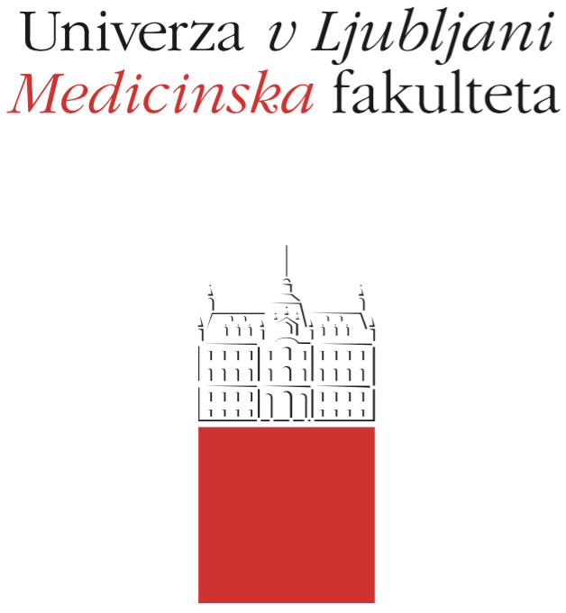

Komisija za študijske zadeve

UL Medicinske fakultete

Vrazov trg 2

SI-1000 Ljubljana

E: ksz@mf.uni-lj.si

T: +386 1 543 7700

Course Regime

Course:

Study Programme:
Dental Medicine

Year of the Course: 4

Semester:
Winter

Course type:
Compulsory

Number of ECTS credits: 4

Lecturer:
Prof. dr. Katarina Šurlan Popovič M.D.

Participating Organisational Units (Departments and Institutes):
Katedra za radiologijo
Katedra za zobne bolezni in normalno morfologijo zobnega organa

Date of Issue: 15.9.2019

A. General part (applies to compulsory and elective courses)

- Course objectives
The student recognizes the importance and principle of radiological imaging techniques used in the diagnosis of disease processes, tooth damage and maxillofacial area. They learn about digital X-ray imaging, computer tomography, interventional radiology, diagnostic ultrasound, and magnetic resonance tomography.
The student recognizes clinical indications for individual radiological imaging methods.
He also acquires knowledge of intraoral imaging (parallel technique and dental crown imaging).
The student acquires knowledge of basic dental and maxillofacial disease processes and their radiological properties. It acquires knowledge of the general principles of the analysis and interpretation of X-ray images and other imaging radiological investigations.

- Comprehensive outline of the course organisation
The subject General and dental radiology consists of lectures, seminars and exercises, the content of which is described below. The schedule is published on the website of the MF, the Department of radiology and in the e-classroom.
Mandatory attendance at lectures, tutorials and seminars is 50%.

Lectures: At the present, students are presented the basics of radiological investigation and intervention methods with basic clinical indications. They learn about the disease processes of the teeth and maxillofacial area and learn the basics of X-ray imaging and other radiological investigations.

Seminars: In the framework of the seminars, the students get acquainted with radiological anatomy and its interpretation on radiological investigations, which is the basis of radiological work.

Tutorials: At the tutorials they learn about the Clinical Institute of Radiology UKC Ljubljana. In practice, they get acquainted with the operation of the appliances and the course of investigations.

- Description of on-going assessment of knowledge and skills
There is no on-going verification.

- Required conditions for the final examination (Course Exam)
The requirement for entering the exam is a 50% attendance in lectures and seminars.

- Final assessment and examination of knowledge and skills (Course Exam)
Upon completion of lectures, seminars and exercises, the Department of radiology issues the deadlines for oral examinations. Prior to the commencement of the course General and dental radiology, the representative of the year will be announced at the Radiology department and will agree on the dates of the exams and other details.

- Other provisions
At the request of the examiner, the student must prove himself with a personal document or a student card.

- Fundamental study material and Supplement reading
Primary:
- GOAZ, PAUL W, AND WHITE, STUART C., EDS. Oral Radiology:Principles and Interpretation. 4th ed. St. Louis: Mosby-Year Book, 2000.
- LANGLAND, OLAF E. ET AL. Principles of Dental Imaging. Lippincott Williams & Wilkins; 2nd ed. 2002)
- Spletno gradivo za predmet Splošna in dentalna radiologija

- Exam topics, clinical presentations and skills

Clinical images | 1 | 2 | D | T
Radiological imaging and interventional methods | 1
Principle of radiological imaging and interventional methods | 1
Basic radiological anthology of teeth, jaws,sinuses, jaw joints and neck
Disease changes and their radiological features | 1
Indications for the use of individual radiological imaging methods | 1
Radiological analysis and interpretation of normal anatomy and disease processes | 1
Radiological diagnostic methods

Digital radiograms and projections | 1
Computer tomography | 1
Magnetic resonance | 1
Ultrasound | 1
Basics principle of contrast media | 1
Skills | 1 | 2 | 3 | 4
Knowledge of types of radiological imaging and interventional methods |  | 2
Knowledge of the principles of radiological and interventional methods |  | 2
Understanding the referral to radiological and interventional methods |  | 2
Understanding the radiological anatomy of the teeth, jaws, sinuses, jaw joint and neck | 1
Understanding the basic principles of digital radiograms analysis |  | 2
Understanding and knowledge of radiological signs of the diseases of the teeth, sinuses, jaws, jaw joints and neck diseases | 1

Clinical images - legend
1 = A medical student must identify and classify a clinical picture from a literature or description to find additional information.
2 = In addition to the knowledge described in section 1, a medical student must also be able to deal with the patient with this clinical picture in everyday practice (for this clinical picture the student knows the symptoms, signs, diagnostic procedure and differential diagnoses as well as general principles of treatment).
D = In addition to the knowledge described in sections 1 and 2, a medical student must be able to make a diagnosis and plan the clinical examinations or procure basic diagnostic tests (eg. laboratory or imaging tests).
T = In addition to the knowledge described in sections 1, 2 and D, a medical student must be able to independently treat illness, injury or disease state (no complications).
Skills - Legend
1 = has theoretical knowledge of skills.
2 = has theoretical knowledge of skills, and has already seen it.
3 = has a theoretical knowledge of the skill, has performed it several times under supervision.
4 = name theoretical knowledge of skills, it can be routinely implemented.

- Other information

Exam topics, student materials and information on recommended sources are published in the e-classroom

* Rules on the verification and assessment of knowledge and skills for a uniform master's degree

