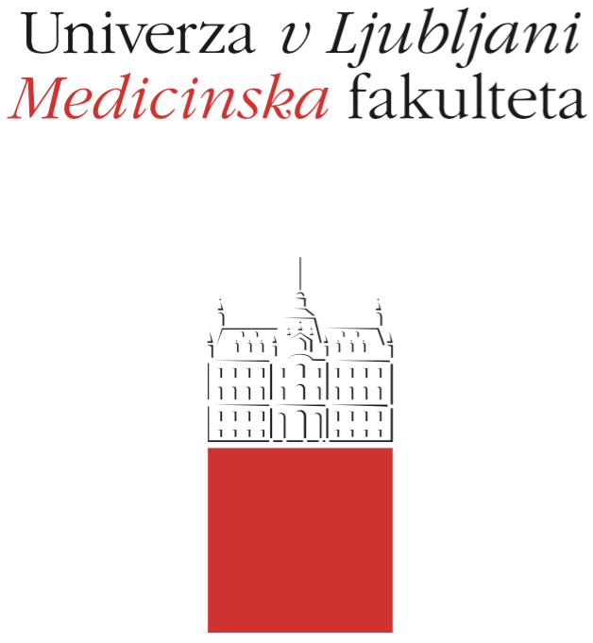

Komisija za študijske zadeve

UL Medicinske fakultete

Vrazov trg 2

SI-1000 Ljubljana

E: ksz@mf.uni-lj.si

T: +386 1 543 7700

Course Regime

Course:

Study Programme:
Medicine Dental Medicine

Year of the Course: 1 2 3 4 5 6

Semester:
Winter Summer Winter and Summer

Course type:
Compulsory Elective

Number of ECTS credits:

Lecturer(s):

Participating Organisational Units (Departments and Institutes):

Parts (Modules) of the Course
1:
2:
3:
4:

Date of Issue:

A. General part (applies to compulsory and elective courses)

- Course objectives
Please describe and briefly list competences, which the student will acquire during the course (overview of the study plan).

- Comprehensive outline of the course organisation
Please state the types and scope of organised study activities within the course according to Article 3 of the regulations (lectures, seminars, clinical practice, other forms of study, clinical cases, etc.), the portion of obligatory attendance at abovementioned organised types of the course, and the procedure on how to substitute and replace missing obligations in the case of justified absence.

- Description of on-going assessment of knowledge and skills
Please state the forms of testing knowledge and skills through on-going assessment during the course (Article 5 of the regulations). State the conditions that have to be met by the student in order to successfully finish the on-going assessment and describe the possibility of achieving possible extra points.
Please state the type of final examination, on-going assessment (number of questions, type of questions according to Article 7 of the regulations, duration of the examination) and the procedure of applying for the examination, if this differs from the procedure stated in Article 24 of the regulations.
Please state in which way readiness for practical or laboratory lessons will be checked. If this requires some previously acquired knowledge, the study material to prepare for the particular lesson or laboratory work has to be clearly defined (Article 15 of the regulations).

- Required conditions for the final examination (Course Exam)
Please state the conditions (previously passed exams, on-going assessment, attendance at organised study activities and other) for taking a course exam according to Article 23 of the regulations.
Define how the student can fulfil the requirements for taking a course exam if he/she has not fulfilled them in the scope of the organised course activities during the course in the current academic year.

- Final assessment and examination of knowledge and skills (Course Exam)
Please state from which forms the final assessment and examination of knowledge and skills is composed of according to Article 5 of the regulations.
Define the composition of the final course exam – number of questions, type of questions (Article 7 of the regulations), time durations of the exam, grading system, contributory component of each assessment (mark breakdown) – in forming the final grade.

In the case when the course exam is composed out of different partial exams, define the minimum rate for successfully passing them and define concretely the conditions for improving or repeating the partial or the entire course exam. Define if the student can, on the final exam (even when he is improving the grade), do just a partial exam from certain parts – if the course exam is formed in that way.

Define the conditions when the student is not allowed to take certain partial exams and, if in the case of repeating the exam, the student is not allowed to take a certain part of the course exam.

Define clearly how the final grade is composed, if there is a group of exams.

- Other provisions
Define which accessories are allowed or needed in certain types of the assessment of knowledge and skills (Article 34 of the regulations).
Define the form of the exam committee (Article 30 of the regulation).
If the study regime defines a seminar or a seminar exam as part of the assessment please state clearly the instructions for how to prepare a seminar, type of seminar, grading system and the deadline to submit the seminar / seminar exam.

- Fundamental study material and Supplement reading
Please state the complete list of primary and secondary study literature.

- Exam topics, clinical presentations and skills
Please list the updated list of examination topics, clinical cases and skills.

- Other information

B. Elective Courses (considered as Elective Course Announcement)

- Participating main and guest lecturers

- Estimated time period in the semester

- Maximum number of students for the elective course (if the number of students able to attend the course is limited)

- Please specify if the elective course is available in English for incoming international students (Erasmus + and others). Please specify any additional conditions in the case that the elective course is available for visiting students.

Additional explications and notes:

- The Course Regime enters in force on the date of issue and remains valid until its revocation or alteration. The Course Regime may not be altered during the academic year. Any changes to the Course Regime may only enter into force starting with the next academic year (changes must be submitted no later than 14 days prior to the start of the academic year as the new Course Regime).

- The Course Regime for compulsory courses must be published no later than 14 days prior to the start of the academic year.

- The Course Regime for elective courses is also considered the Elective Course Announcement and must be published no later than the 30th of July prior to the start of the academic year in which it enters in force.

- The Course Regime must be published in Slovenian and English.

- In the Course Regime, the »Regulations for the Assessment of Knowledge and Skills for the Single-Cycle Master Study Programmes Medicine and Dental Medicine« will be referred to as ''Regulations''.

In case of any further questions, please contact the Study Affairs Commission of the UL MF, via e-mail: ksz@mf.uni-lj.si.

Ta navodila pred shranjevanjem pobrišite:
- Za izpolnjevanje tega obrazca uporabite pisavo Garamond, 12pt.
- Dokument shranite v .pdf.

