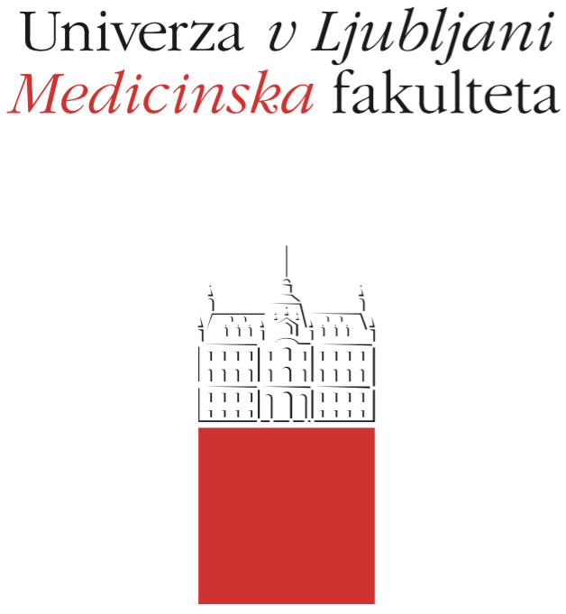

Komisija za študijske zadeve

UL Medicinske fakultete

Vrazov trg 2

SI-1000 Ljubljana

E: ksz@mf.uni-lj.si

T: +386 1 543 7700

Course Regime

Course: Basics of biostatistics

Study Programme: Medicine, Dental Medicine

Year of the Course: 2

Semester: Summer

Course type: Compulsory

Number of ECTS credits: 4

Lecturer(s): prof. dr. Maja Pohar Perme

Participating Organisational Units: Institute for Biostatistics and Medical Informatics

Date of Issue: 15.9.2020

- Course objectives
Learn the purpose and types of statistical methods; understand the basics of statistical inference; be able to properly display large amounts of data and results of statistical analyses; be able to properly interpret the results of statistical analyses; be able to plan the collection of empirical data and choose appropriate methods of statistical analysis for them; be able to understand and critically evaluate the statistical analyses described in the technical and scientific literature.

- Comprehensive outline of the course organisation
Lectures: Wednesdays, 12-14h, Medical Faculty, Korytkova 2
Labs: 9 labs, computer lab IBMI, Vrazov trg 2
According to the current epidemiological situation, a part of the course may be carried out online.
Labs are conducted in groups of students – known at the start of semester
Labs are compulsory and a prerequisite for the written exam
Students presenting a valid excuse perform the lab exercise individually and present it at the next session.

- Description of on-going assessment of knowledge and skills
Testing readiness for a lab session: each student must fill out a part of basic lecture contents before each lab session, the basic understanding of these topics is assessed during each lab session. Readiness is a prerequisite to be present at the lab session. Instructions are published online in “Spletna učilnica” (Moodle). A good performance during the lab session and the best projects may be rewarded with extra points.
The maximum number of extra points is 12 (percents at the exam). Extra points are valid only in the current school year.

- Required conditions for the final examination (Course Exam)
All 9 lab sessions must be completed (see rules above) and required projects must be completed in order to be allowed to write the exam.

- Final assessment and examination of knowledge and skills (Course Exam)
The exam is a combination of multiple choice questions and open questions. No negative points may be given. The exam lasts for 45 minutes.
Exam criterium:
insufficient (1-5) 0,00 % to 59,99 %,
sufficient (6) 60,00 % to 67,99 %,
good (7) 68,00 % to 75,99 %,
very good (8) 76,00 % to 83,99 %,
very good (9) 84,00 % to 91,99 %,
excellent (10) 92,00 % to 100 %.
Information: IBMI, Vrazov trg 2, (01) 543 77 70, e-mail: ibmi@mf.uni-lj.si

- Other provisions
The following items are allowed during the exam: 1 A4 paper with formulae (no worked out examples are allowed), calculator (no mobile phones), statistical tables

Exam topics:
- Basic concepts of probability and statistics.
- Probability distributions: Binomial and Normal distributions.
- Principles and methods of data presentation: graphical presentations, measures of central tendency, measures of variability
- Diagnostic tests: conditional probability, law of total probability, Bayes formula, specificity, sensitivity. positive and negative predictive value,
- Introduction to parameter estimation and statistical hypothesis testing.
- Confidence intervals.
- Univariate and bivariate analysis of numeric variables.
- Univariate and bivariate analysis of categorical variables.
- Linear regression and correlation.
- Nonparametric statistical methods.
- Design of experiments

