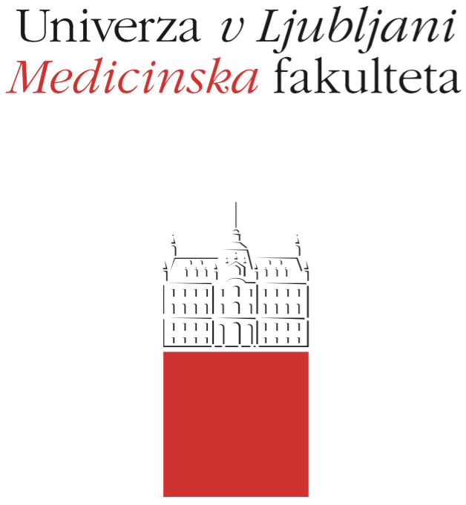

Komisija za študijske zadeve

UL Medicinske fakultete

Vrazov trg 2

SI-1000 Ljubljana

E: ksz@mf.uni-lj.si

T: +386 1 543 7700

Course Regime

Course: Children's and Preventive Dentistry 1 (OPZ1)

Study Programme:
Medicine Dental Medicine

Year of the Course: 1 2 3 4 5 6

Semester:
Winter Summer

Course type:
Compulsory Elective

Number of ECTS credits: 3

Lecturer(s): Assoc. Professor Alenka Pavlič

Participating Organisational Units (Departments and Institutes): Department of Paediatric and Preventive Dentistry

Parts (Modules) of the Course
• Aspects of paediatric dentistry
• Diagnosis of caries in children and adolescents
• Treatment of dental caries
• Prevention of dental caries (diet, oral hygiene, fissure sealing, fluoride
• Endodontics of primary teeth
• Endodontics of young permanent teeth with underdeveloped dental root

Date of Issue: September 18th 2020

A. General part

- Course objectives

The student is acquainted with certain areas of paediatric dentistry: diagnosis of dental caries in children and adolescents, prevention of caries (nutrition, oral hygiene, fissure watering, fluorides) and the treatment of caries and tooth pulps (endodontics of primary teeth, endodontics of permanent teeth with immature tooth root).
The student acquires knowledge and understands the particularities of the dental clinical examination of children and adolescents, knows the principles of planning dental care in this population and develops the appropriate skills in oral and written reporting, data collection and interpretation and communication (establishing an appropriate relationship with the child-patient and parents).

- Comprehensive outline of the course organisation

Lectures: 15 hours, tutorials and seminar discussions on clinical procedures (training): 16 hours, seminars prepared by students on the required topics: 8 hours.

- Description of on-going assessment of knowledge and skills

At training, the student is assessed by the Clinical assistant.

- Required conditions for the final examination (Course Exam)

The presence is mandatory at tutorials and seminar discussions on clinical procedures (i.e. training) as well as at seminars, at the lectures recommended (70 % presence is mandatory).
Successfully completed training and presented seminar.

- Final assessment and examination of knowledge and skills (Course Exam)

The OPZ1 exam takes place at the end of the academic year, on three pre-agreed exam deadlines, in the form of a written examination. A student registered for the exam writes the exam on the day at 9 am, in the lecture room at the Dental Clinic (depending on the number of registered candidates, the exam can also be held at other locations). The exam consists of 20 multiple-choice questions with one correct answer; the duration of the exam is 30 minutes.

- Other provisions

- Fundamental study material and Supplement reading

• selected chapters: Koch G, Poulsen S. Pediatric Dentistry - a clinical approach, 1st or 2nd ed.; or Koch G, Poulsen S, Espelid I, Haubek D Pediatric Dentistry: A Clinical Approach, 3rd Edition, Wiley, 2016.
• Pavlič A. Endodontics of primary and immature permanent teeth: a book of pediatric and preventive dentistry - selected chapters. Faculty of Medicine, Department of Paediatric and Preventive Dentistry, Ljubljana, 2014.
• selected articles published in the Slovenian Dental Journal Zobozdravstveni vestnik.

